- Static Routing – Concepts and Practical Work

Q1. Open Cisco Packet Tracer and set up a simple network with two routers connected via a serial cable, assigning IP addresses to both router interfaces?

- I started by adding two Cisco 2811 routers to the Packet Tracer workspace. Their serial ports were connected directly, and I set Router0 to 199.168.1.1/30 and Router1 to 199.168.1.2/30. The /30 mask gives the connection two usable host addresses.
- Next, I brought up both interfaces using the no shutdown command and made sure the serial connection was active. I used ping to check whether Router0 could reach the IP address of Router1.
- Result: Both routers are configured on the same serial subnet. The new 199.x addressing should be tested in Packet Tracer to confirm successful replies.

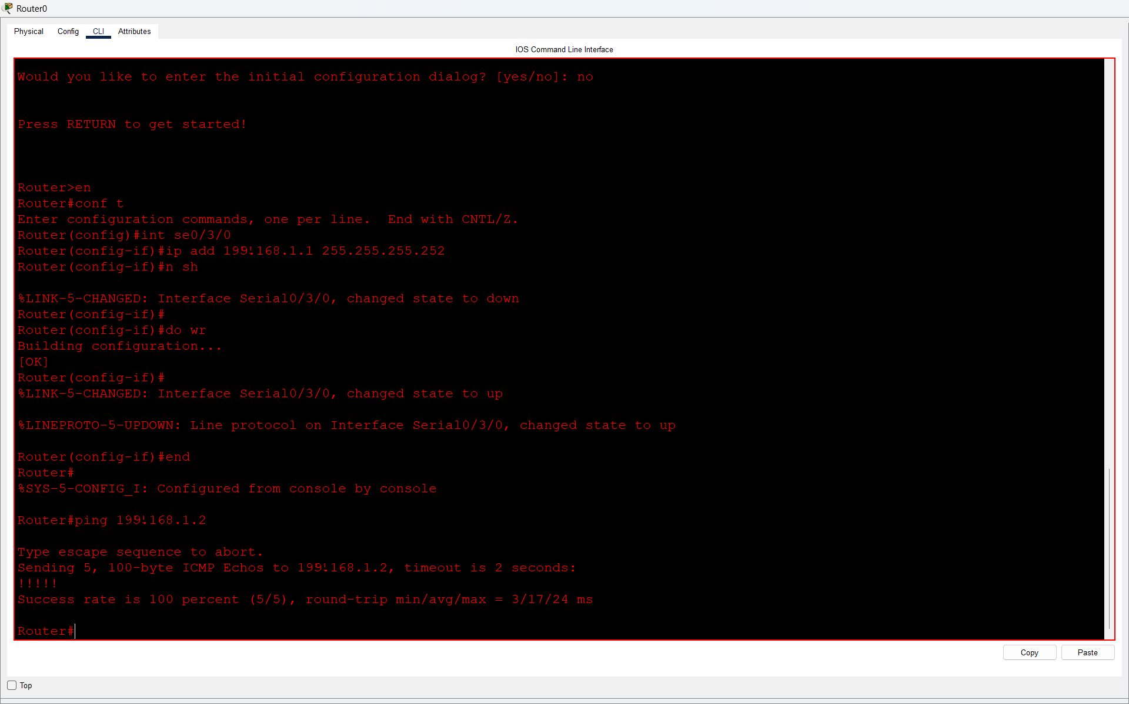
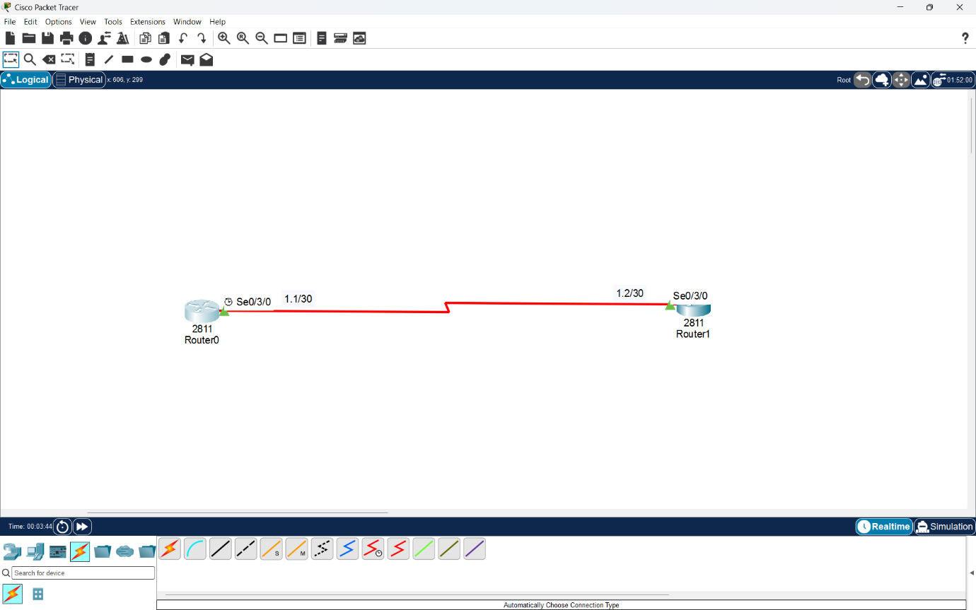

Q2. On Router1 in Cisco Packet Tracer, configure a static route so it can reach a PC connected to Router2’s LAN network. Test connectivity using the ping command from Router1 to the PC?

Answer
- First, I arranged a router-to-router serial connection. Router1 was linked to a switch, and two PCs were attached to the switch to form a separate LAN.
- For the PCs, I planned the 199.168.1.64/26 network, which has 62 usable addresses. Router1 provides the LAN gateway and can assign host settings to the PCs using DHCP.
- Router0 needs an explicit path to this network, so I entered the following command in global configuration mode:
ip route 199.168.1.64 255.255.255.192 199.168.1.2
- I then planned a connectivity check from Router0 to PC0 (199.168.1.66). The PC must have its LAN interface configured correctly and must point to Router1 as its gateway.
- Result: The static route tells Router0 where to send packets destined for 199.168.1.64/26. A fresh ping test is required to verify the changed configuration.
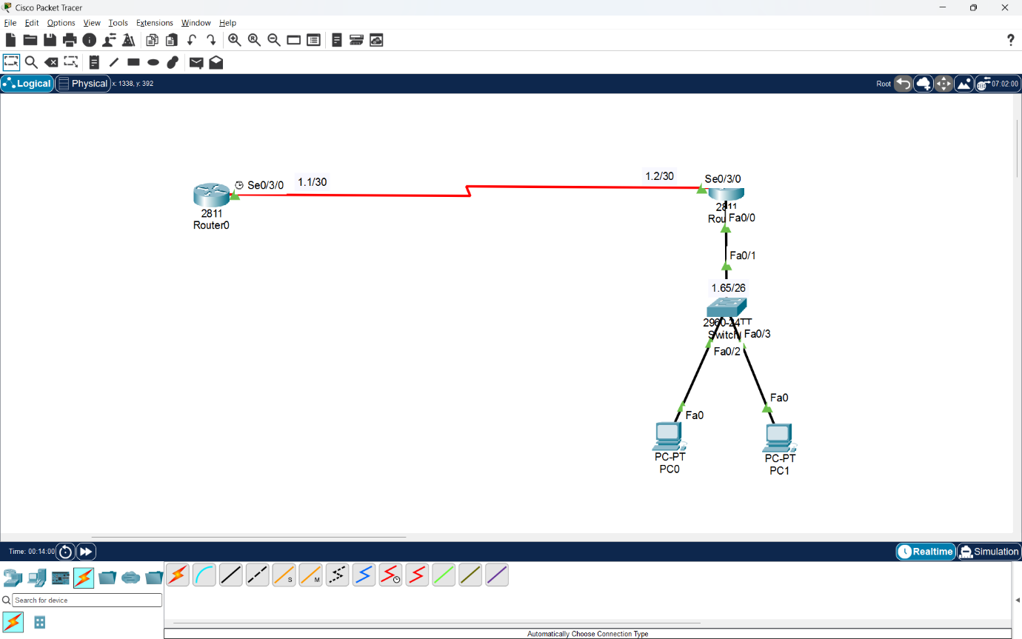

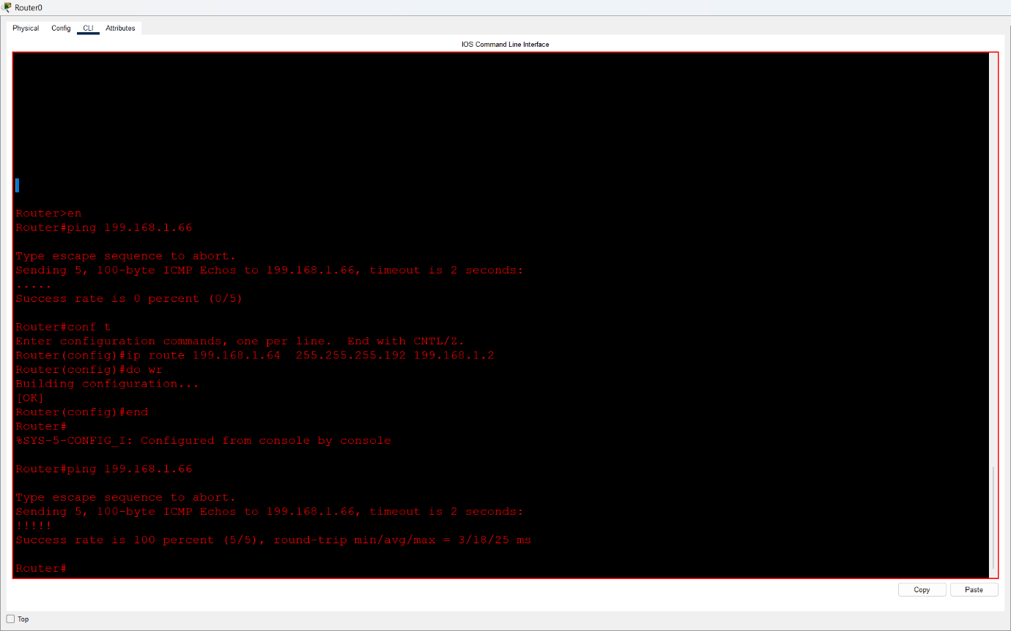

Q3. Simulate a Zomato-style delivery network: imagine Router1 represents an Ahmedabad branch and Router2 represents a Surat branch. Configure static routes so that devices in each city’s LAN can communicate with each other through the routers?

Answer
- To represent delivery operations in two cities, I used Router0 for the Ahmedabad office and Router1 for the Surat office. A serial connection acts as the link between these two locations.
- Both office LANs contain a switch and two computers. I used separate subnets for the cities and planned DHCP settings so that the PCs can obtain their addresses and gateways automatically.
- The Ahmedabad LAN is assigned 199.168.1.128/26, whereas the Surat LAN uses 199.168.1.64/26. For the connection between routers, I reserved 199.168.1.0/30.
- A router does not automatically know the remote branch network when no routing protocol is running. Therefore, I created one static route on each side for the other city’s LAN.
- Ahmedabad Router0:
ip route 199.168.1.64 255.255.255.192 199.168.1.2
- Surat Router1:
ip route 199.168.1.128 255.255.255.192 199.168.1.1
To check end-to-end communication, I would ping a Surat PC from an Ahmedabad PC and perform the reverse test. If a ping fails, I would check interface status, gateways, and the route entries.
- Result: Each router has a defined next hop toward the opposite branch. The revised IP plan must be tested to establish that packets are delivered in both directions.

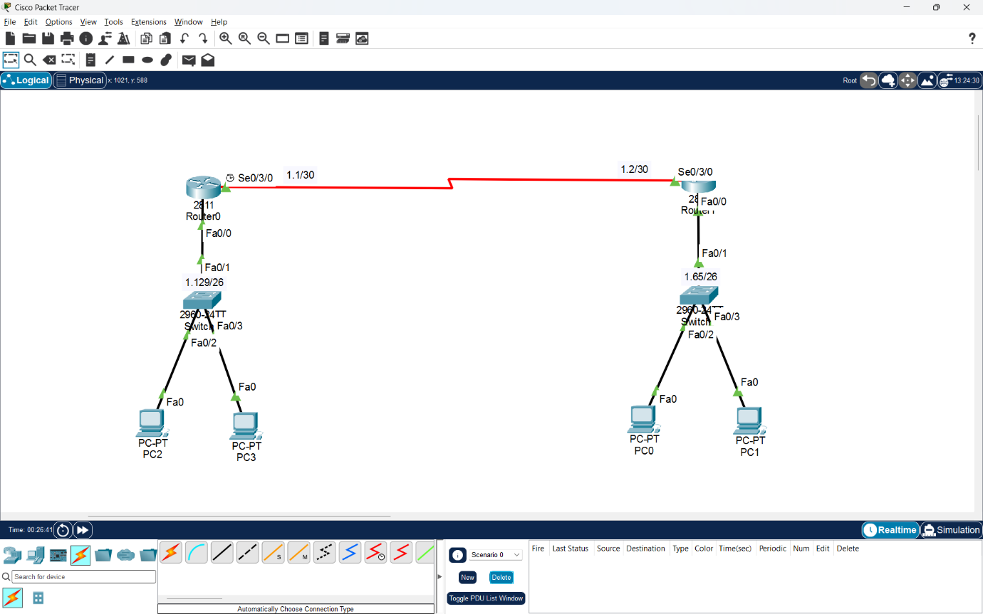
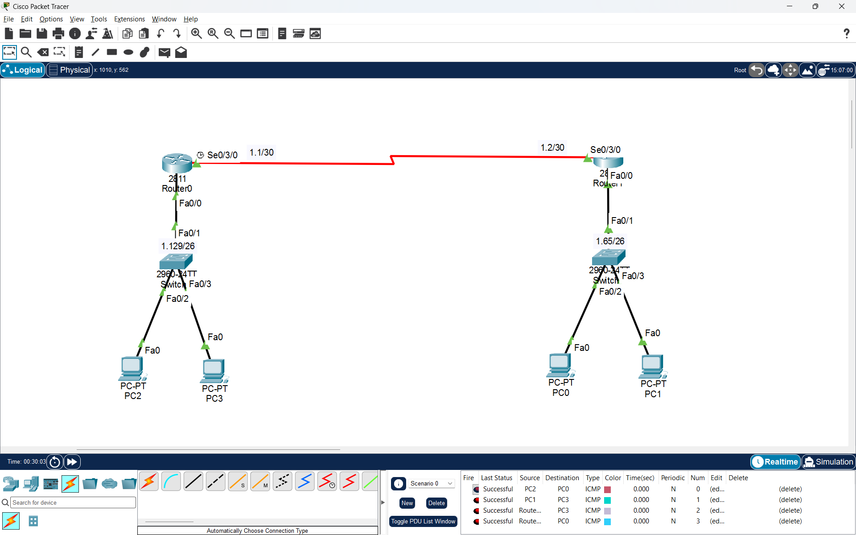

Q4. List two advantages and two disadvantages of static routing compared to dynamic routing, using examples from real-life apps like IRCTC or Swiggy to illustrate your points.<br><br><em><strong>Hint:</strong> Think about how static routes might impact delivery or booking updates in these apps.</em>?

Answer
Static routing means that the network administrator specifies the destination and next-hop address directly. Dynamic routing uses protocols that share routing details so devices can adjust their forwarding tables when the network changes.
- Advantages of Static Routing
1. Greater Control Over Traffic
    - Because an administrator enters the route manually, traffic can be directed over a specific link without a routing protocol choosing the path.
    - Example: A small Swiggy branch setup with one dedicated link can use a fixed route for predictable office communication.
2. Fewer Router Resources Used
    - With no dynamic routing updates to process, a small router spends less memory, CPU time, and bandwidth on exchanging route information.
    - Example: A small IRCTC help-desk network could use static routes where the network layout is fixed and routing changes are uncommon.
- Disadvantages of Static Routing
1. Routes Need Manual Maintenance
    - If a link is changed or unavailable, the route might stop working. Without a preconfigured alternative or another failover method, an administrator must correct the path.
    - Example: A broken connection between Swiggy offices could interrupt internal updates until the routing problem is resolved.
2. Not Suitable for Frequent Expansion
    - Every additional router or destination can require more entries. Managing those entries across many devices increases work and the possibility of configuration errors.
    - Example: In a large IRCTC network with multiple offices, adding or relocating a subnet could require route changes on several routers.
- Conclusion
Overall, manually configured routes work well when networks are small and connections stay consistent. Where links and destinations frequently change, dynamic routing usually reduces administrative effort.

